N+ Network Security
DAY 1
1. Use Wireshark to capture network traffic while you load www.spotify.com in your browser, then identify and note down at least two DNS packets and two HTTP or HTTPS packets in the capture.
=
Packet No. | Protocol | Source → Destination | Description
15 | DNS | Your PC → DNS Server | Standard query for www.spotify.com
16 | DNS | DNS Server → Your PC | Standard query response with Spotify IP address
24 | HTTPS (TLS) | Your PC → Spotify Server | Client Hello to establish a secure HTTPS connection
30 | HTTPS (TLS) | Spotify Server → Your PC | Server Hello and encrypted HTTPS data exchange

2. Simulate a DNS lookup for www.flipkart.com using the nslookup command in your terminal and write down the IP address returned along with a brief explanation of what this result means.
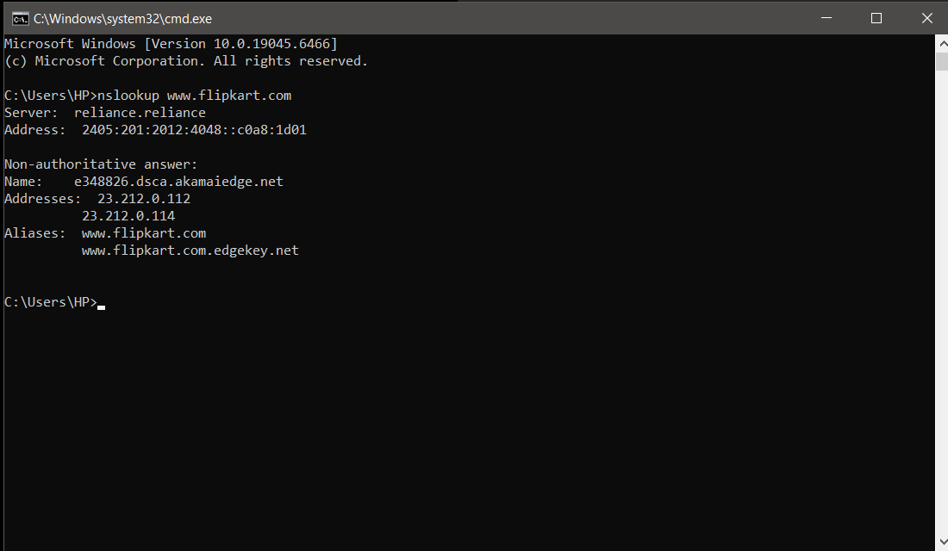
3. Explain the difference between HTTP and HTTPS by listing 3 key differences, and give a real-world example of an app or website you use that relies on HTTPS for secure communication.
=
Feature | HTTP | HTTPS
Security | Data is not encrypted. | Data is encrypted using SSL/TLS.
Port Number | Uses port 80. | Uses port 443.
Safety | Less secure and vulnerable to data theft. | More secure and protects sensitive information like passwords and payments.

4. Open Wireshark and filter for DNS protocol traffic. Try searching for a new website (one you haven't visited recently) in your browser and describe the sequence of DNS queries and responses you observe.<br><br><em><strong>Hint:</strong> Look for packets with 'Standard query' and 'Standard query response' in the Info column.</em>
=
Step | Packet Type | Description
1 | Standard Query | My computer sent a DNS request asking for the IP address of www.canva.com.
2 | Standard Query Response | The DNS server replied with the IP address of www.canva.com.
3 | Standard Query | The browser requested additional DNS records (such as IPv6 or related domains).
4 | Standard Query Response | The DNS server returned the requested records, allowing the browser to connect to the website.

5. Pick any one protocol from DNS, DHCP, FTP, or SNMP (other than HTTP/HTTPS) and write a short scenario describing how it would be used in a real-world app or service you use (for example, how DHCP helps your phone connect to WiFi when you open Instagram at a cafe).
= Scenario: DHCP (Dynamic Host Configuration Protocol)
When I connect my phone to the Wi-Fi at a café and open Instagram, the DHCP protocol automatically assigns my phone an IP address, subnet mask, default gateway, and DNS server. This allows my phone to connect to the internet without any manual network configuration, so I can browse Instagram immediately.

